30.8: a) 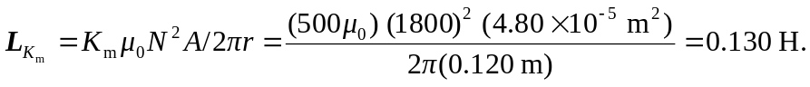
b) Without the material, 